Raspberry Pi Pico Board：

1. Introduction：

Raspberry Pi Pico is a low-cost, high-performance microcontroller board with flexible digital interfaces. It integrates the RP2040 microcontroller chip designed by Raspberry Pi, with dual-core Arm Cortex M0+ processor running up to 133 MHz, embedded 264KB of SRAM and 2MB of on-board Flash memory, as well as 26 multi-function GPIO pins. For software development, either Raspberry Pi's C/C++ SDK, or the MicroPython is available. In this tutorial, we will use MicroPython.

**2. Features：**

* RP2040 microcontroller chip designed by Raspberry Pi
* Dual-core ARM Cortex M0+ processor, flexible clock running up to 133 MHz
* 264kB of SRAM, and 2MB of on-board Flash memory
* Castellated module allows soldering direct to carrier boards
* USB 1.1 Host and device support
* Low-power sleep and dormant modes
* Drag & drop programming using mass storage over USB
* 26 multi-function GPIO pins
* 2×SPI, 2×I2C, 2×UART, 3×12-bit ADC, 16×controllable PWM channels
* Accurate on-chip clock and timer
* Temperature sensor
* Accelerated floating point libraries on-chip
* 8×Programmable IO (PIO) state machines for custom peripheral support

1. Parameters：

Microcontroller: RP2040 microcontroller chip

CPU: Dual-core Arm Cortex-M0+ @ 133MHz

USB-to-serial chip: Built-in USB1.1 PHY host and device support, drag-and-drop download program through USB identification as mass storage

Working voltage: 3.0V-3.6V

Working current: average 80mA

Supply current: 500mA

External power supply: DC power supply is 6-12V (recommended 9V), USB power supply is 5V.

Flash Memory: Built-in 2MB

SRAM: Built-in 264KB

Integrated crystal oscillator: 12MHz

**Dimension Diagram：**

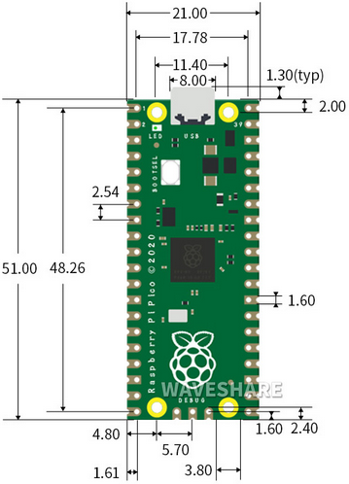

Schematic Diagram：

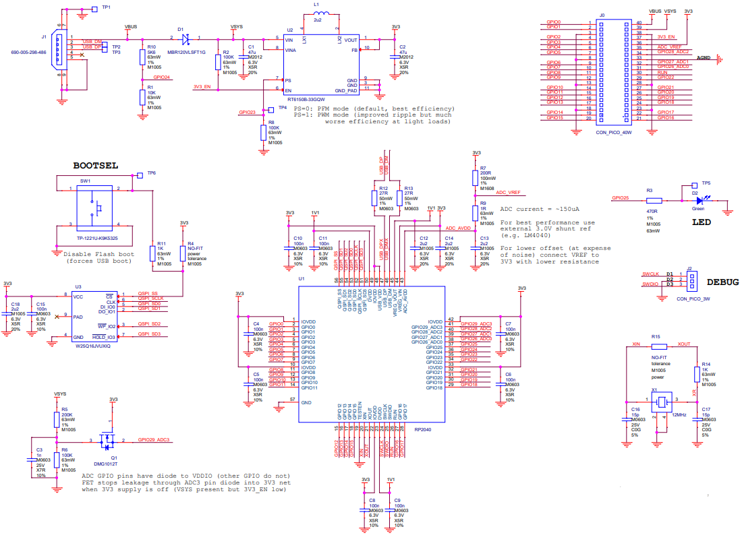

1. **Pin out**

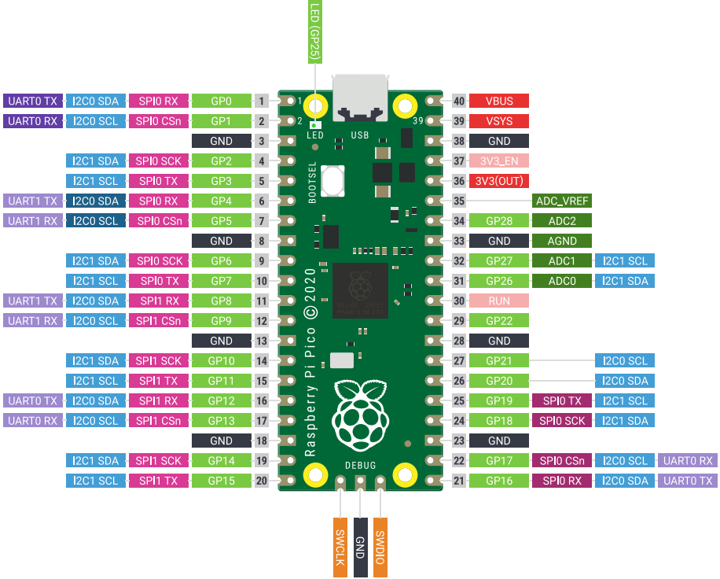

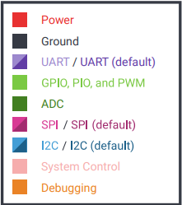

|  |  |
| --- | --- |
| GND | Ground pin |
| Power | VBUS(microUSB voltage)、VSYS(2-5VDC input voltage)、3V3(3.3V output voltage) 3V3_EN(Enables Pico) |
| System Control | run (enable or disable the RP2040 microcontroller or reset) |
| ADC | Raspberry Pi Pico has a total of 5 ADCs with a resolution of 12 bits, namely ADC0 (GP26), ADC1 (GP27), ADC2 (GP28), ADC3 (GP29), ADC4. Among them, ADC3 (GP29) is used to measure VSYS on the Pico board; ADC4 is directly connected to the built-in temperature sensor of RP2040. ADC_VREF can be connected to an external accurate voltmeter as ADC reference. The ADC_GND pin serves as the ground reference. |
| PWM | Raspberry Pi Pico has 16 PWM channels，each of channel can control frequency and duty cycle.GPIO pin is switched to PWM |
| UART | Two UART： UART0,UART1 |
| I2C | Two types of I2C： I2C0 I2C1 |
| SPI | Two types of SPI：SPI0,SPI1 |
| Debugging | used in debugging code |

Related information：<https://datasheets.raspberrypi.com/pico/pico-datasheet.pdf>